- Configure 2 slave machines in Jenkins master.
Step 1: Launch 2 instances named slave-01 and 02, also enter bash script in user data to install java.
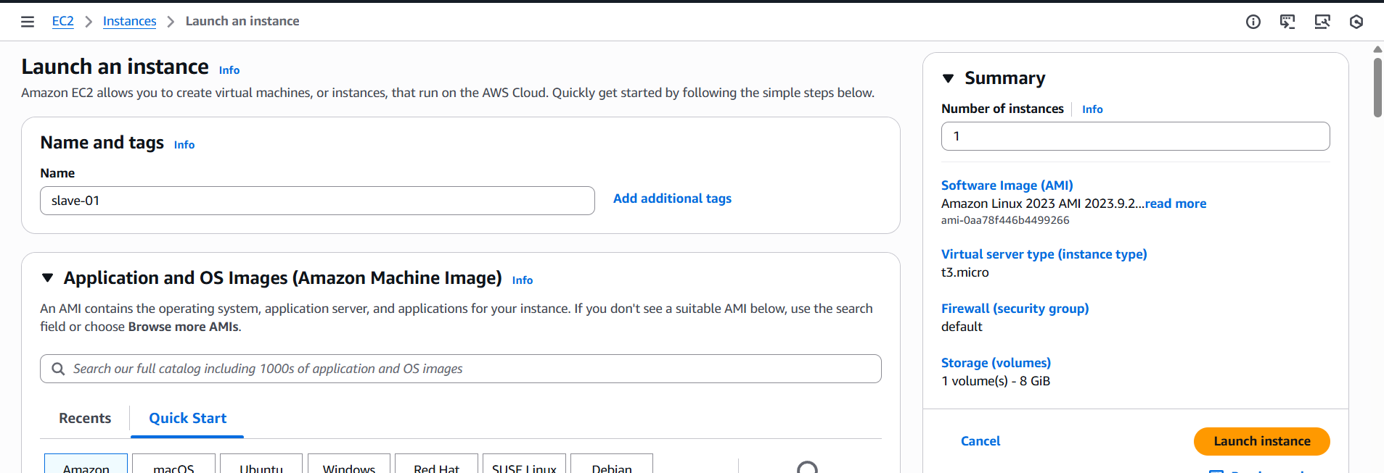
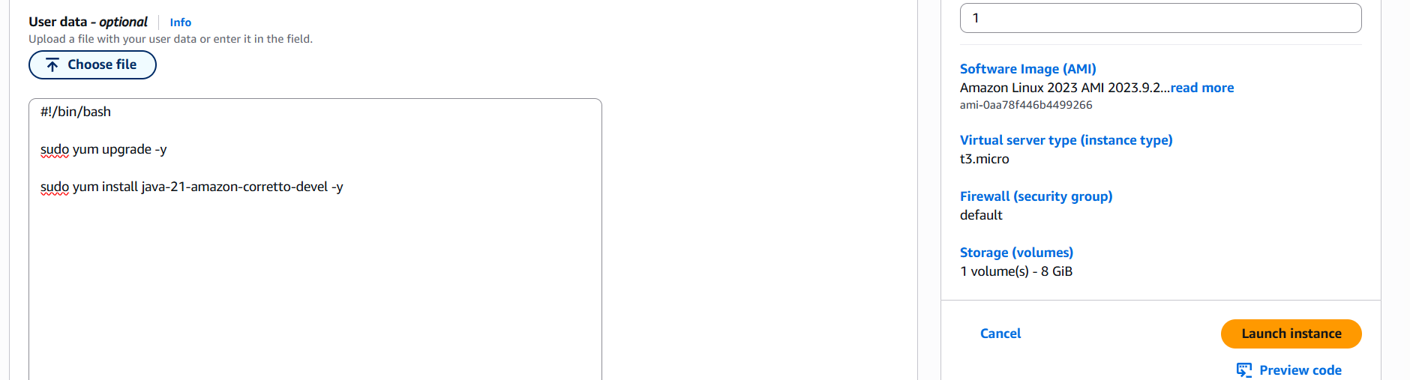
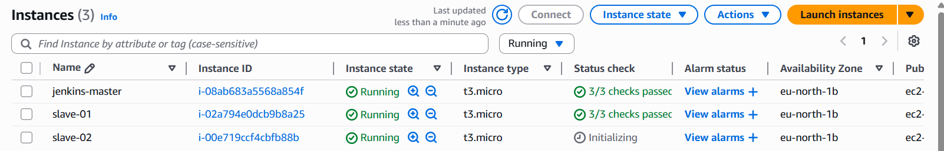
Step 2: Login to slave-01 instance and do following steps to configure to master.
Steps to be done on slave
- Login to slave machine..
- switch to root user
- Create ssh-keygen
- cat id_rsa.pub > authorized_keys
- chmod 700 authorized_keys
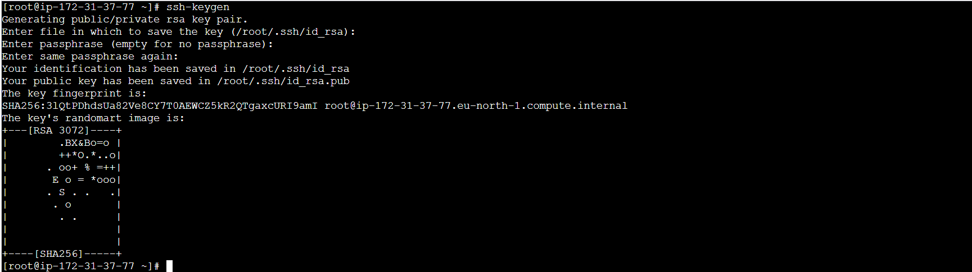

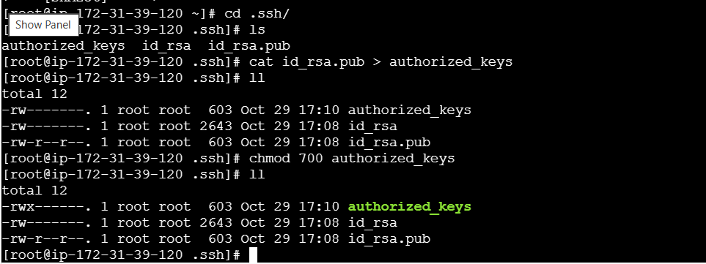

Steps to be done on master machine:
- Login to master machine
- switch to root user.
- mkdir -p /var/lib/jenkins/.ssh
- cd /var/lib/jenkins/.ssh
- ssh-keyscan -H SLAVE-NODE-IP-OR-HOSTNAME >>/var/lib/jenkins/.ssh/known_hosts
- # ssh-keyscan -H 172.31.38.42 >>/var/lib/jenkins/.ssh/known_hosts
- chown jenkins:jenkins known_hosts
- #we need to change the owner as we ran ssh-keyscan command using “root” user.
- # default user of Jenkins will be “jenkins”
- chmod 700 known_hosts
- # DOne !!
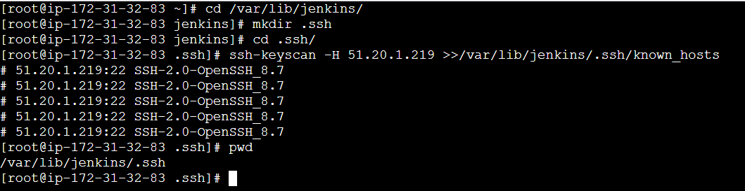
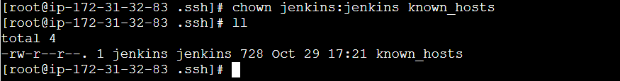
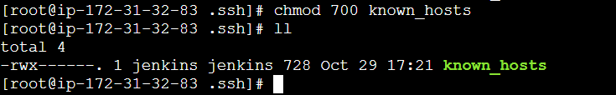

Steps to be done on jenkins GUI:
- Go to manage jenkins
- open manage node
- under launch method select "Launch via SSh"
- Host "public ip of slave"
- creditals: select user with private key
- enter ec2-user as name and paste the pem key.
- host key verification startegy to be selected
- save..
- we are good with the master and slave configuration
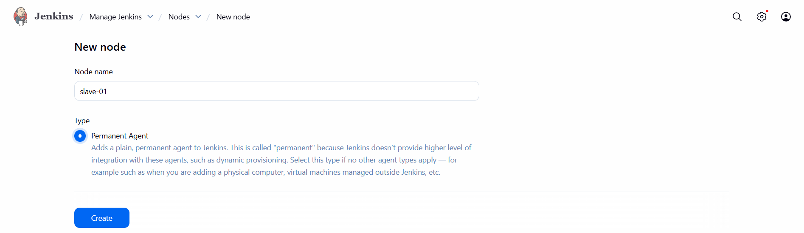
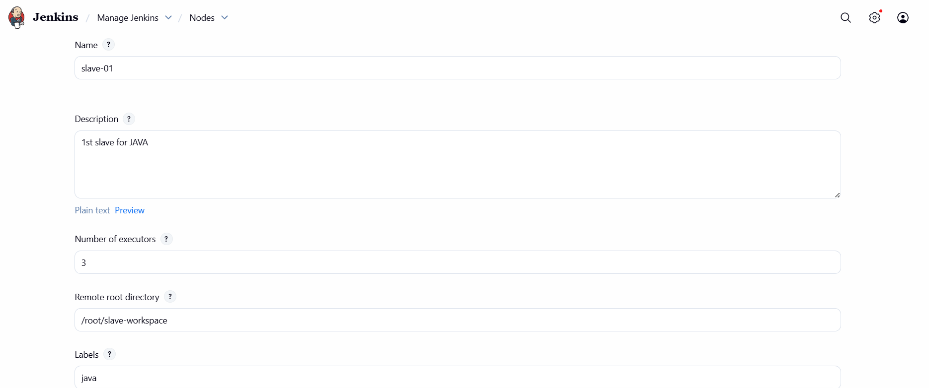
Repeat the same steps to configure to Master
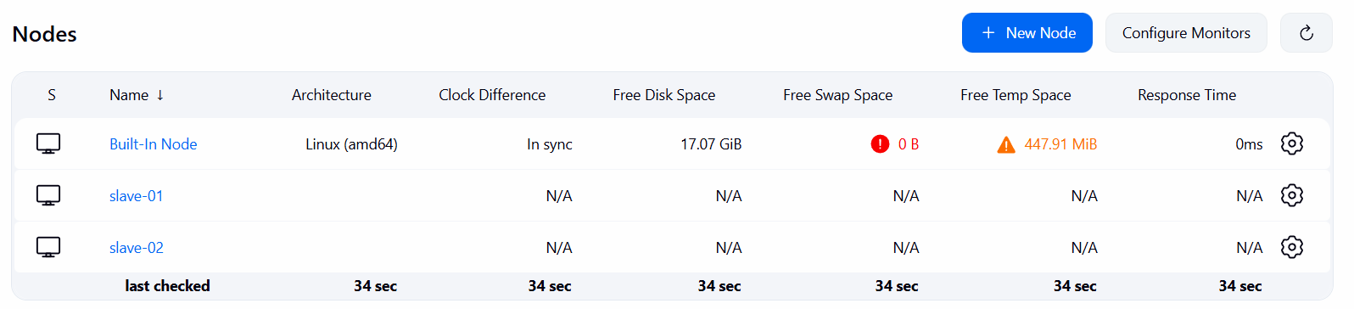

- Configure webhooks to Jenkins job.
Step 1: Goto GitHub RepositorysettingswebhooksAdd webhook Paste Jenkins URL with prefix /github-webhook/select Add webhook.
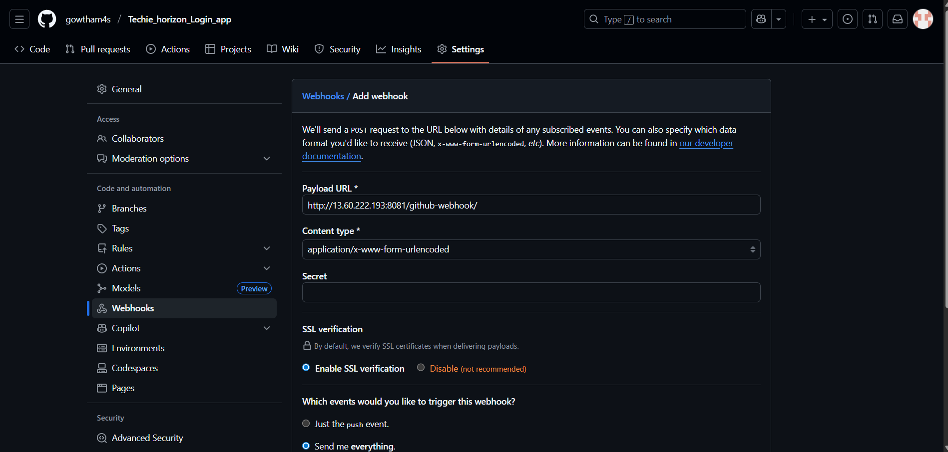

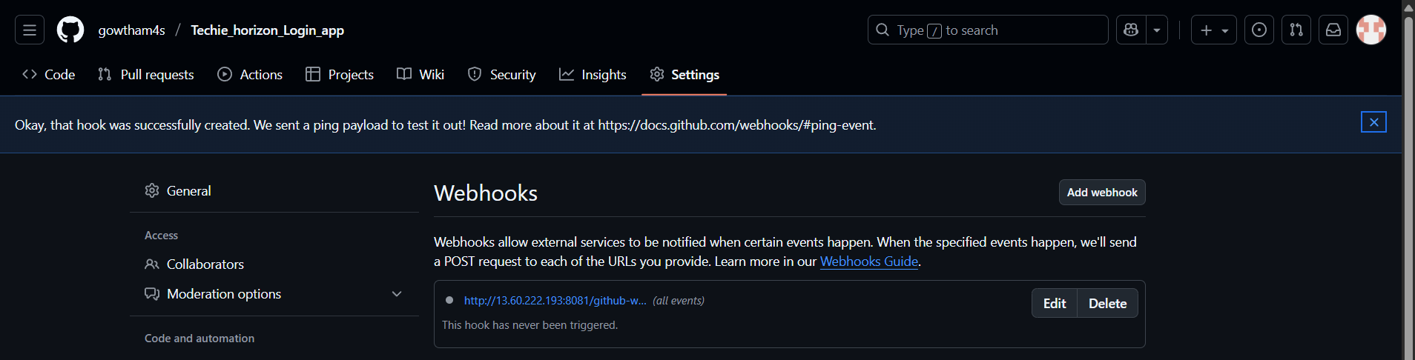
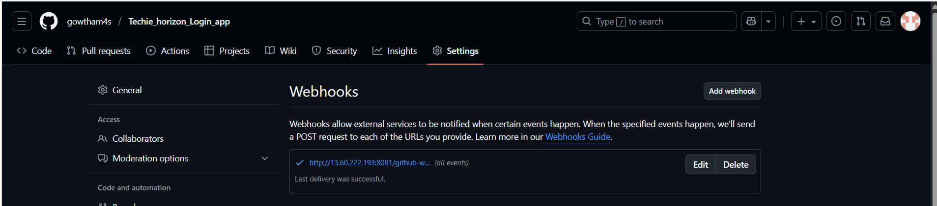

- Configure poll scm and build periodical options in Jenkins job.
Step 1: Goto JenkinsJobconfigureTrigersPoll SCMSchedule time to trigger the jobsave.
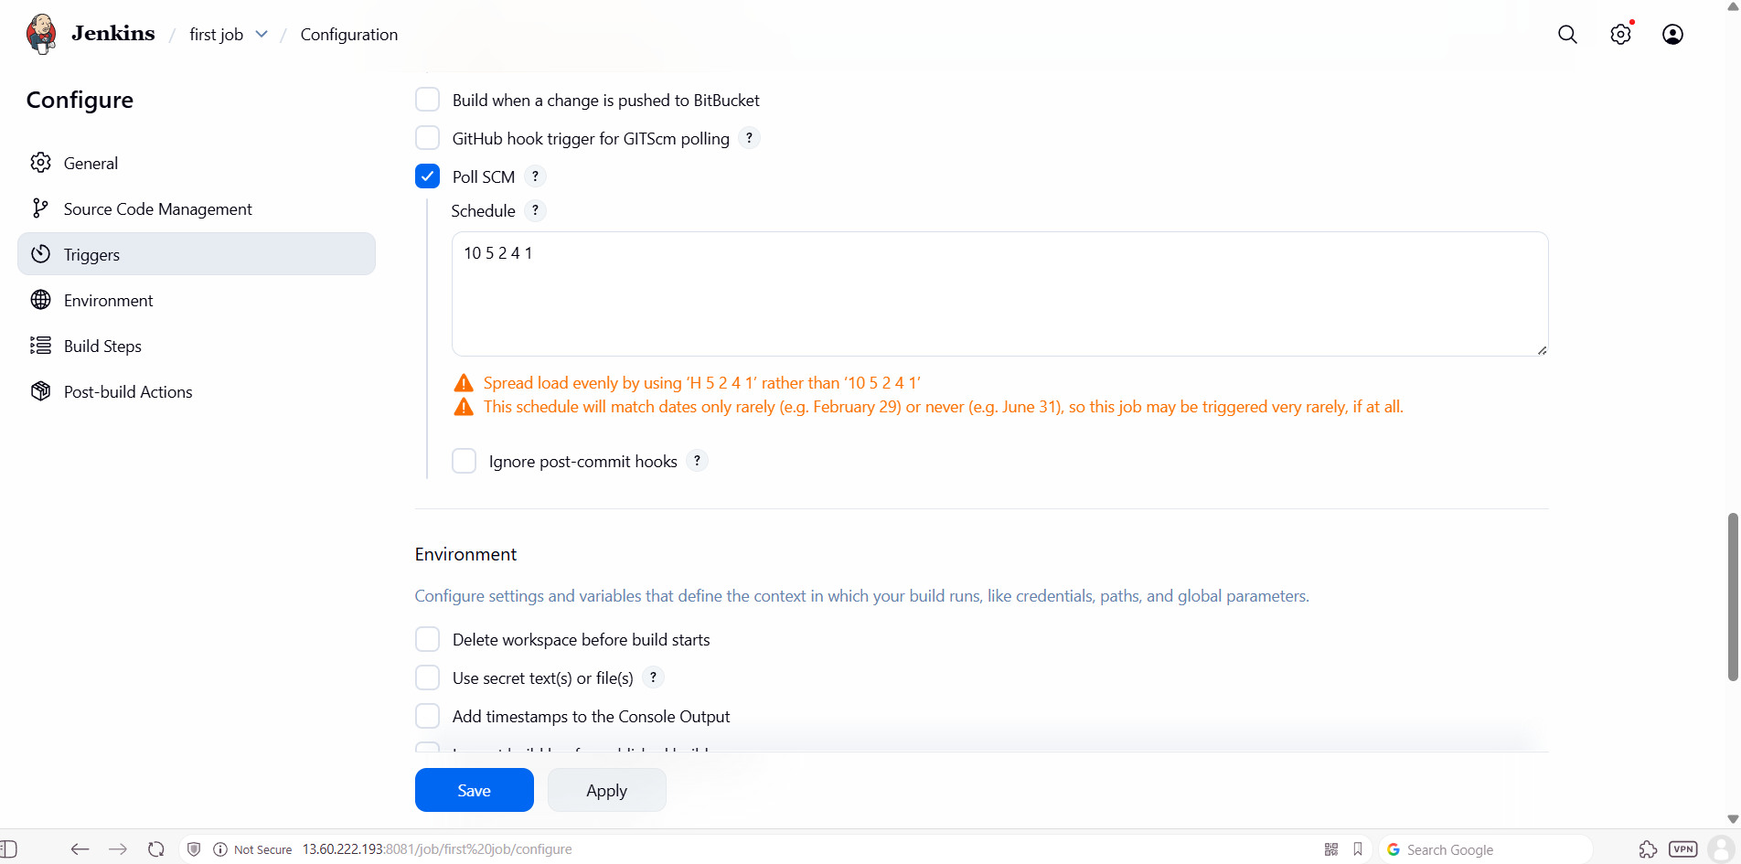
Step 2: Goto JenkinsJobconfigureTrigersBuild periodicallySchedule time to trigger the jobsave.
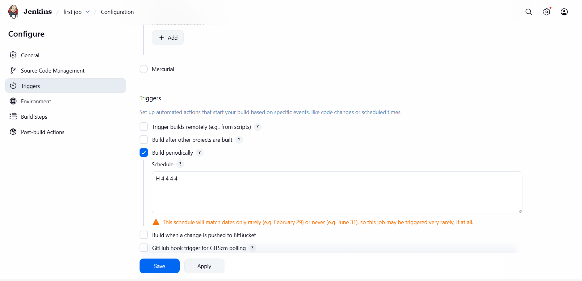

- Take backup of Jenkins server by using bash script.
Step 1: Create a bash script to take backup, give executable permission and execute the script.
#!/bin/bash
# Variables
JENKINS_HOME="/var/lib/jenkins"
BACKUP_DIR="/backup/jenkins"
DATE=$(date +'%Y-%m-%d_%H-%M-%S')
BACKUP_FILE="$BACKUP_DIR/jenkins_backup_$DATE.tar.gz"
# Create backup directory if not exists
mkdir -p "$BACKUP_DIR"
# Stop Jenkins service (optional but safer)
echo "Stopping Jenkins service..."
systemctl stop jenkins
# Take backup
echo "Taking backup of Jenkins directory..."
tar -czvf "$BACKUP_FILE" "$JENKINS_HOME"
# Start Jenkins service back
echo "Starting Jenkins service..."
systemctl start jenkins
echo "Backup completed successfully!"
echo "Backup file stored at: $BACKUP_FILE"
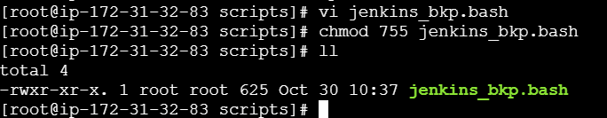
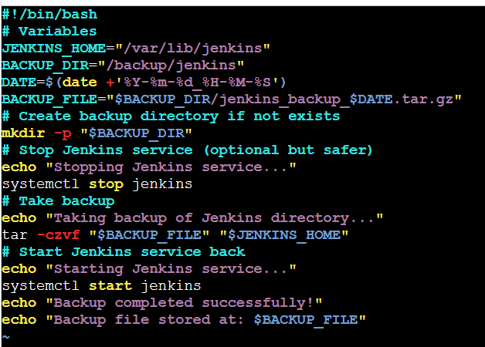
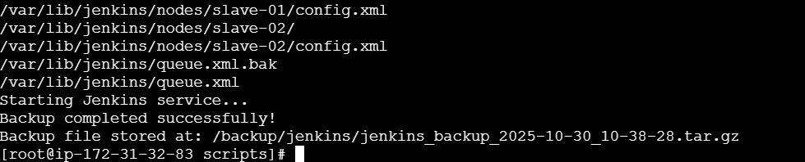

- Take backup of Jenkins using rethin backup plugin.
Step 1: Goto JenkinsManage Jenkinspluginsavailable pluginssearch and install thinbackup
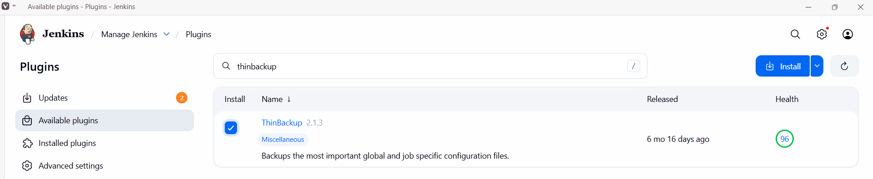
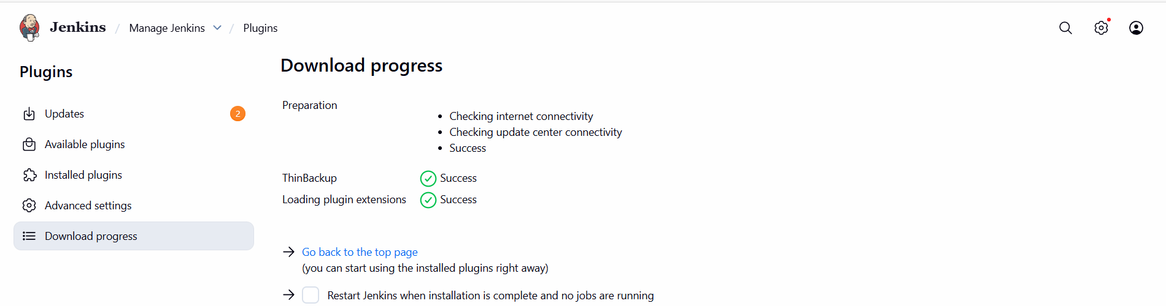
Step 2: Goto Manage Jenkins ThinBackupClick Backup now.
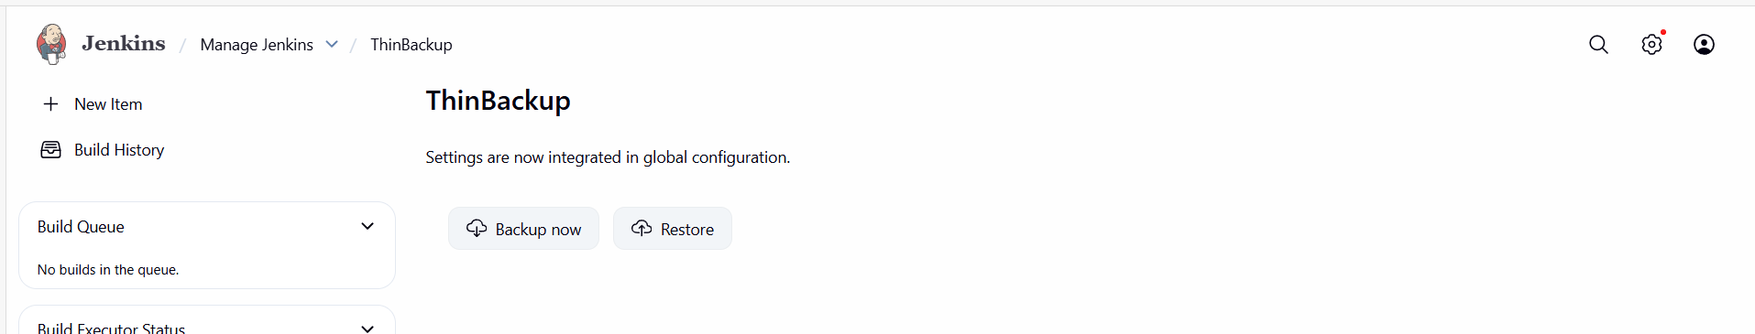

- Setup a new Jenkins server and dump the backup taken in task4.
Step 1: Launch a new instance.
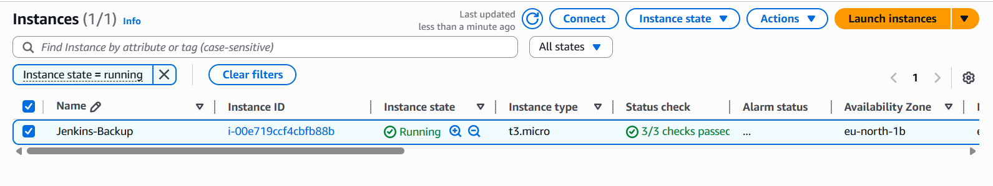

Step 2: Login to the instance where the backup is.
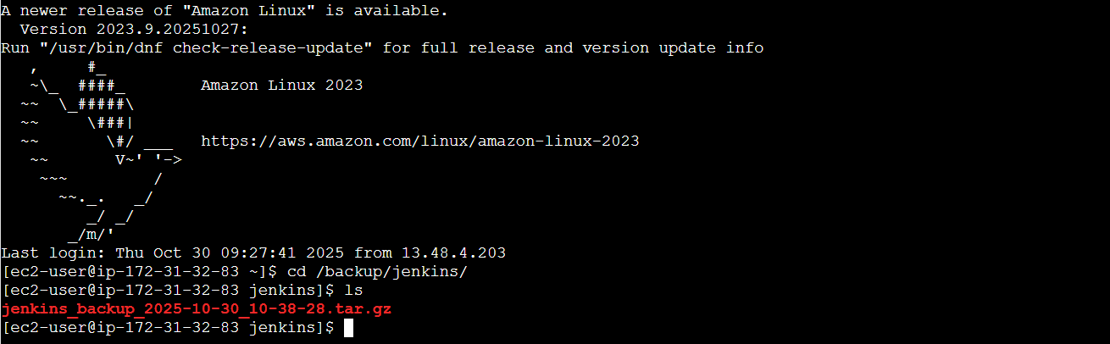
Step 3: Take a copy of .pem key of new instance and make a file in this instance and give permission.
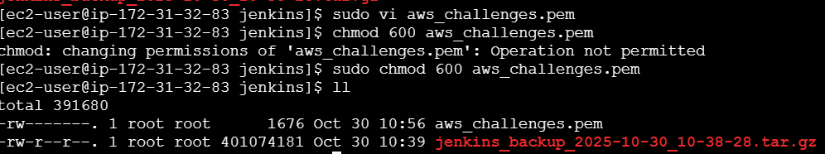
Step 4: Now execute scp -i security_key.pem file.tar ec2-user@public_ip:/tmp to send backup file to new server.
Step 2: Login to new server, move the backup file to /var/lib/Jenkins and extract it.
